Selenium: Selenium WebDriver is a web framework that permits you to execute cross-browser tests. This tool is used for automating web-based application testing to verify that it performs expectedly.

Selenium WebDriver allows you to choose a programming language to create test scripts. As discussed earlier, it is an advancement over Selenium RC to overcome a few limitations. Selenium WebDriver is not capable of handling window components, but this drawback can be overcome by using tools like Sikuli, Auto IT, etc.

**Selenium** is a free (open-source) automated testing framework used to validate web applications across different browsers and platforms. You can use multiple programming languages like Java, C#, Python etc to create Selenium Test Scripts. Testing done using the Selenium testing tool is usually referred to as Selenium Testing.

1)install selenium on powershell

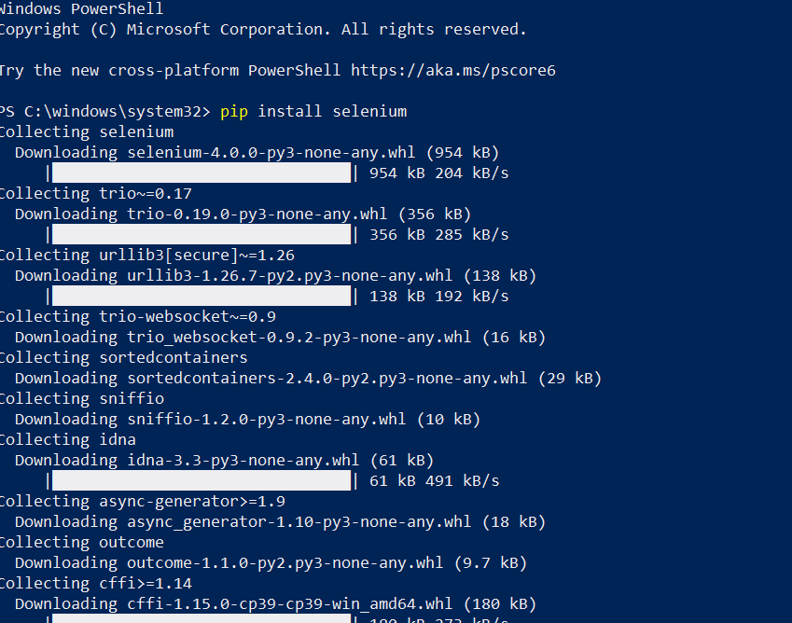

2)then download webdriver using link https://chromedriver.chromium.org/downloads

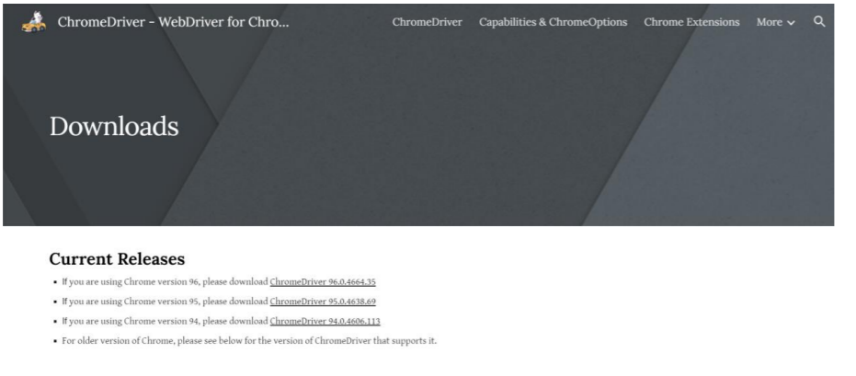

3)select correct option

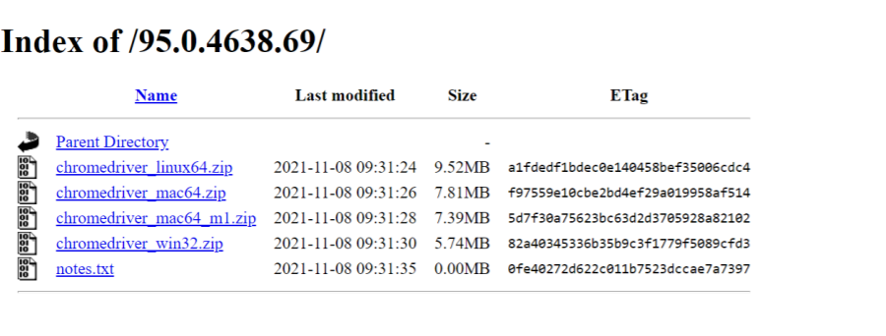

4)write following script in python

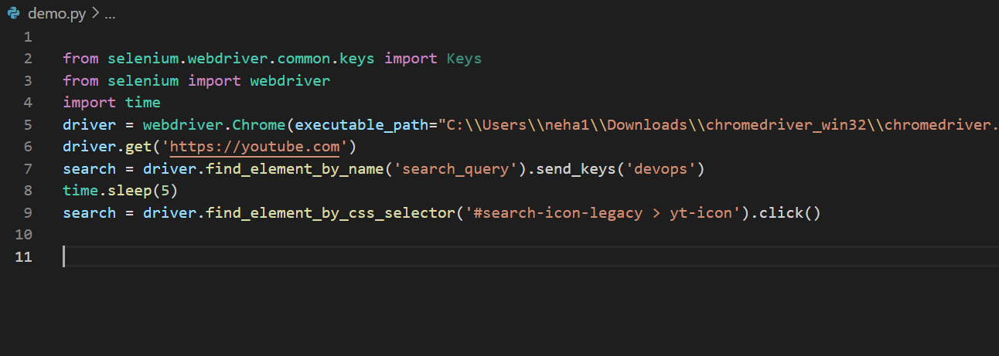

5 )run script this will get opened write click on this page

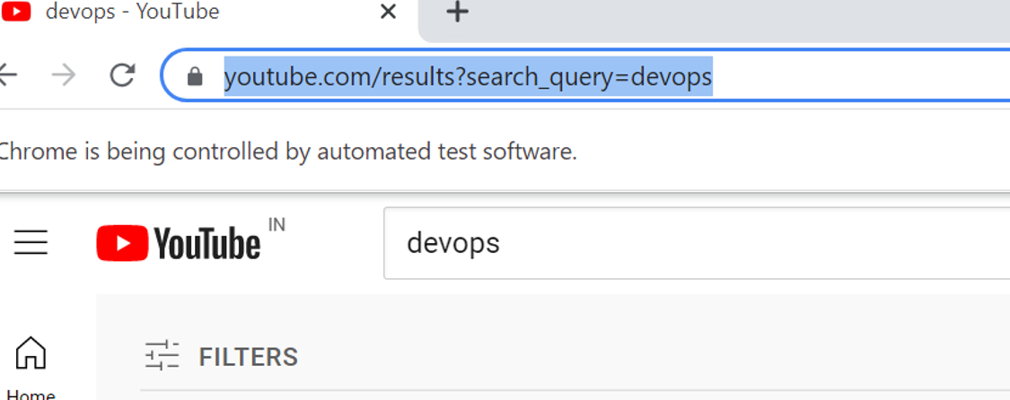

6)whatever page will gets opened right click and click on inspect

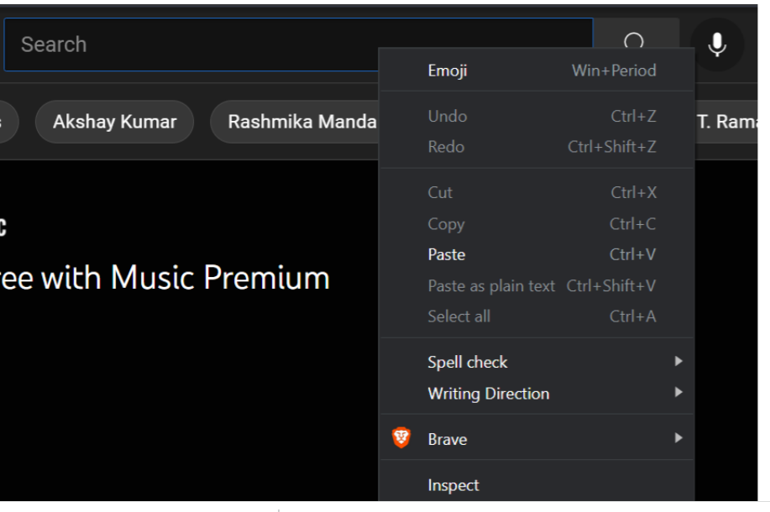

7)click on search button will get highlighted part

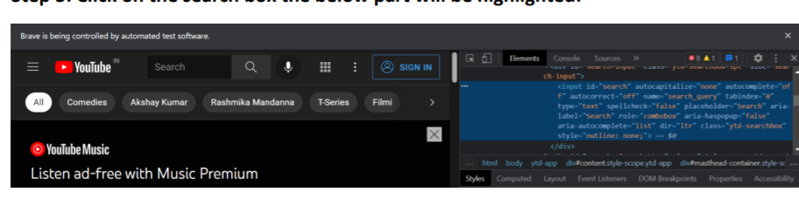

8)then copy that path and paste in script and run script

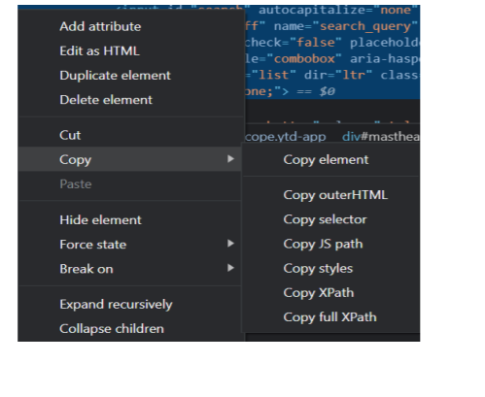

9)then it will open youtube and search whatever we given in script

